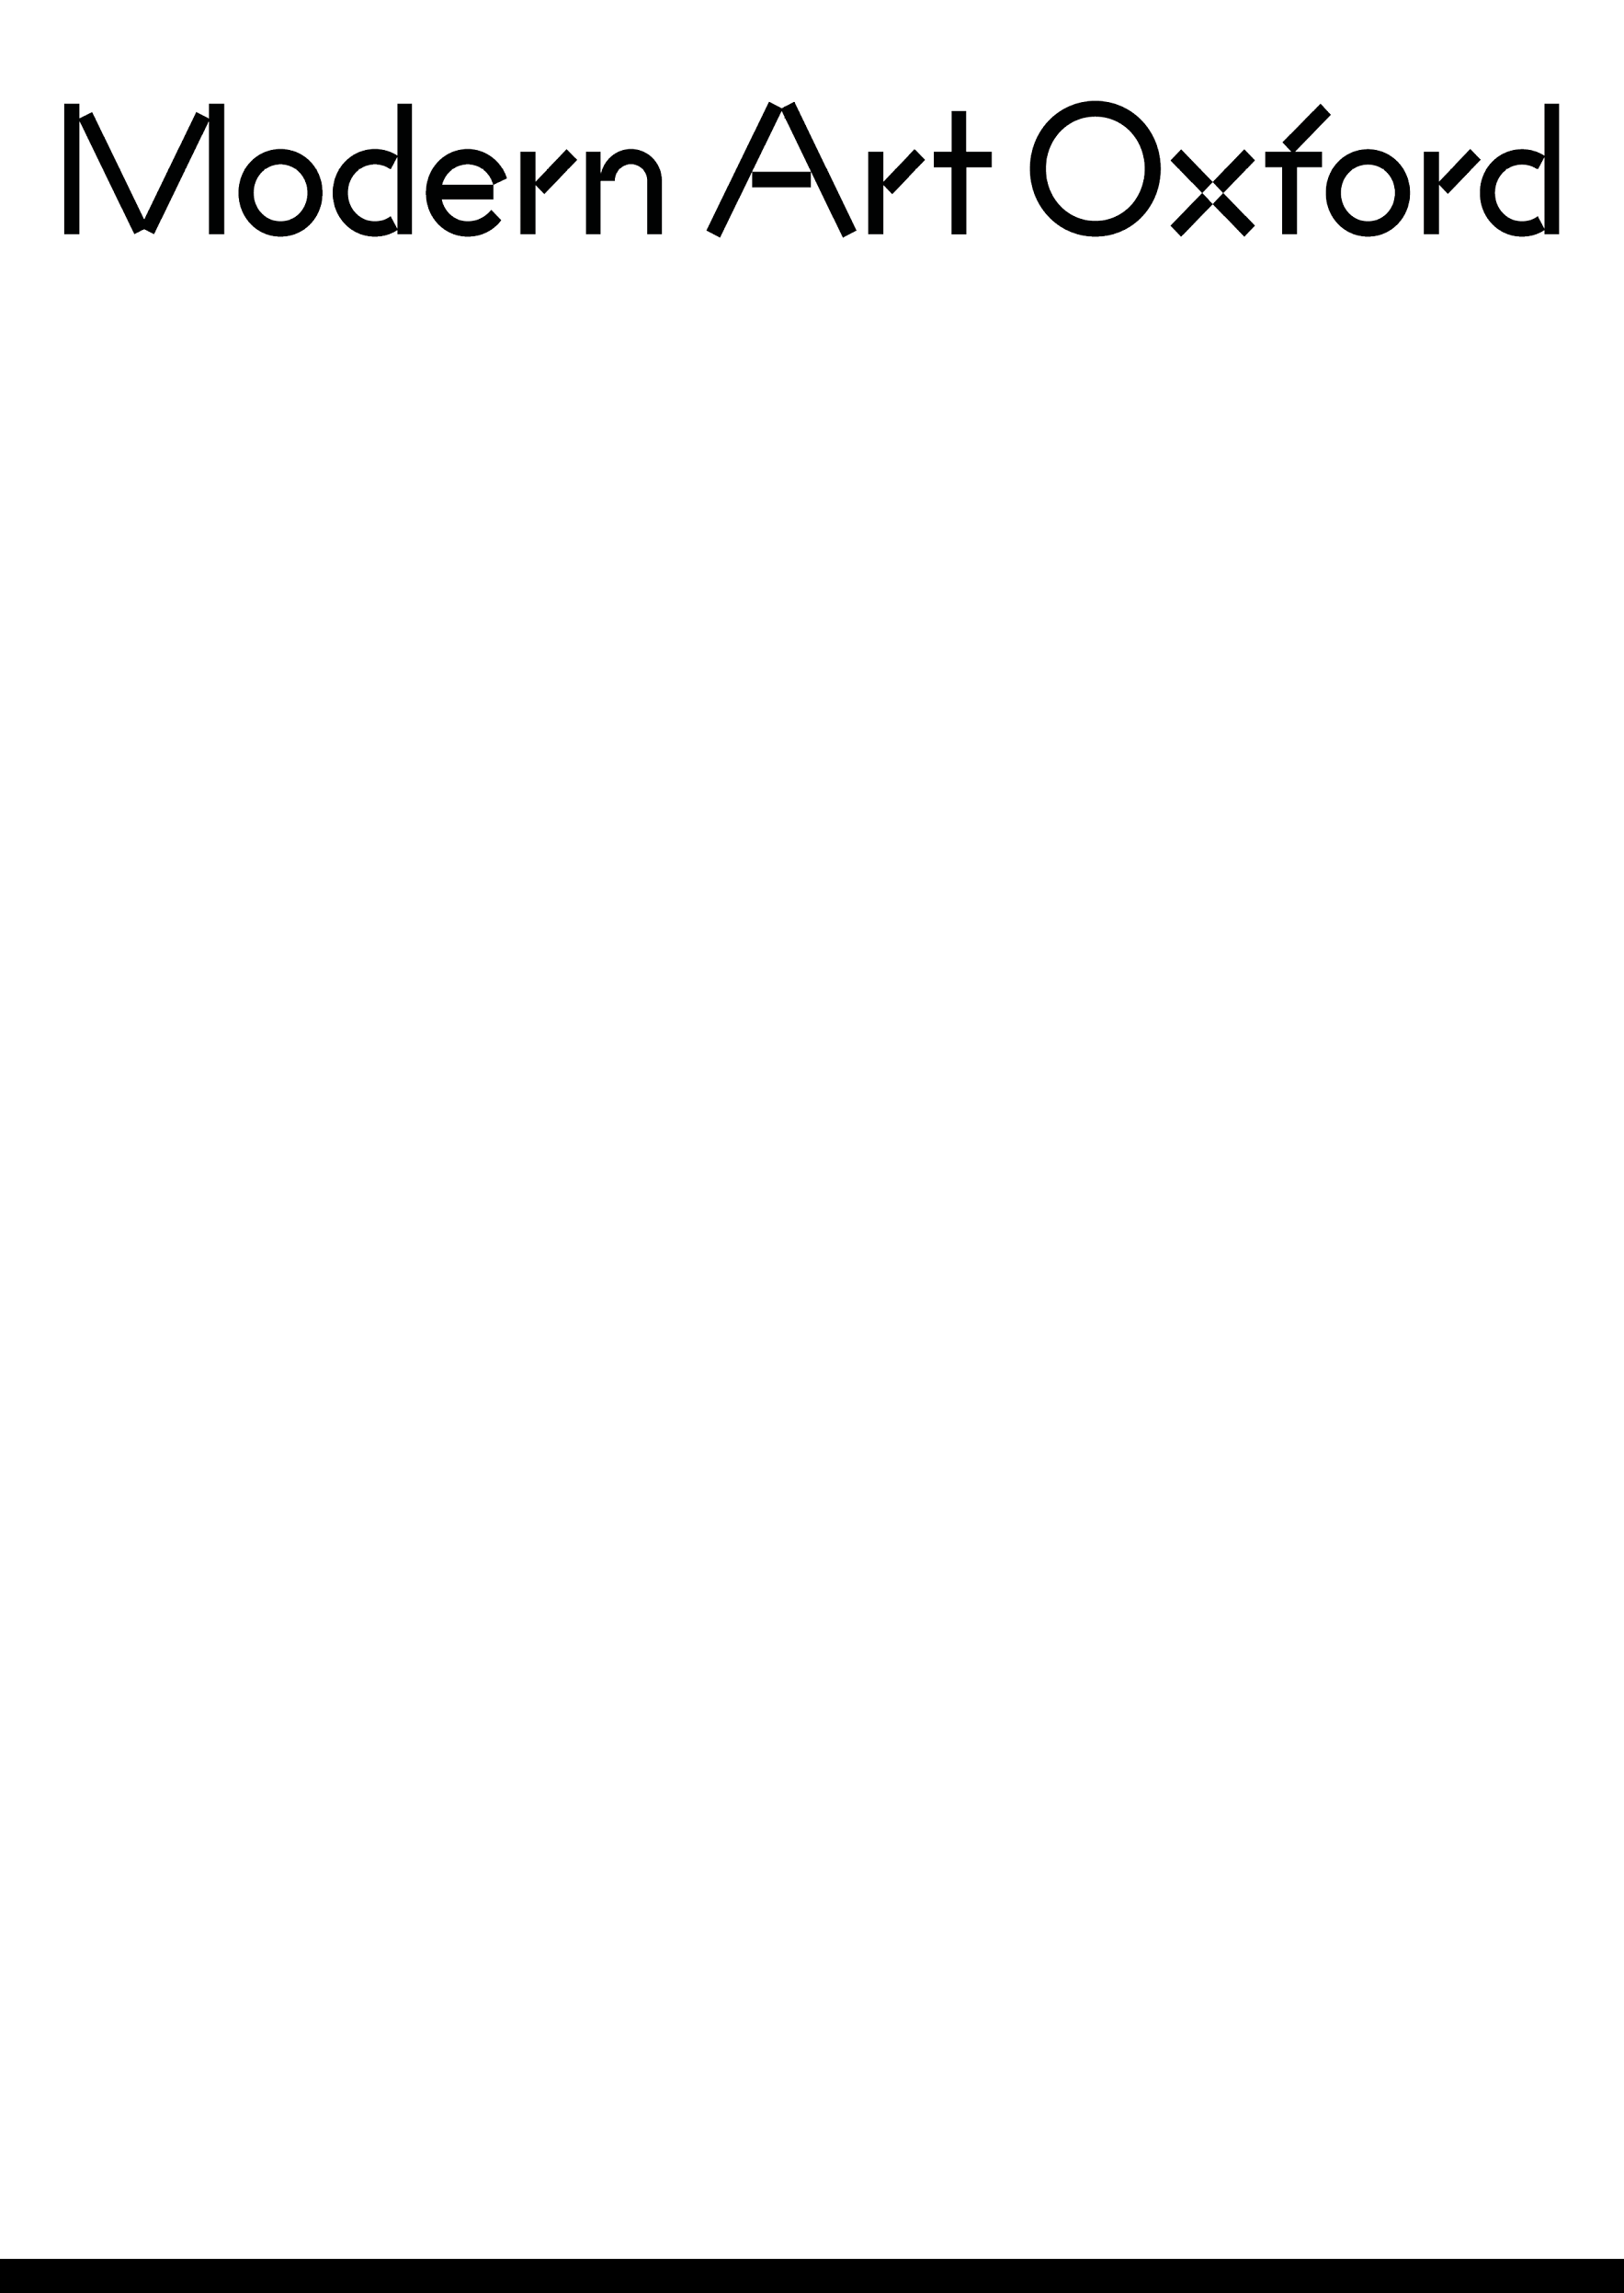

How can collective practices help us to embrace uncertainty and complexity?
Brief for collaborative micro-commission

The Brief

In 2026, Modern Art Oxford, one of the UK’s leading contemporary art spaces, celebrates six decades of internationally acclaimed exhibitions. The year’s 60th anniversary celebrations mark a pivotal shift in our programming ethos, with a strengthened focus on commissioning new work, underpinned by experimental, cutting-edge, and multidisciplinary approaches. Kicking oﬀ this new commissioning chapter, this open call exhibition will run alongside a major new solo exhibition by artist Mike Nelson, who will also form part of the selection panel.
This open call invites artists based in the South East of the UK to respond to a central enquiry/question: How can collective practices help us to embrace uncertainty and complexity? The resulting group exhibition will showcase three 'micro-commissions', an opportunity intended to support the production of small-scale, experimental works that champion collective and cooperative working practices.
Recent years have seen seismic shifts across the world - from the escalating climate crisis to a deeply divisive political and economic landscape. We are seeing the ripple of this at regional and local levels. In a time deﬁned by such intense polarisation, this open call aims to explore what unites us, and how embracing collective practices can allow us to work across diﬀerence and serve as a catalyst for forward-thinking and collaborative resilience.
We are interested in how shared methodologies can help us not only navigate uncertainty, but thrive within it. By grounding this enquiry in our speciﬁc locality in the South East of the UK, we intend to investigate how collective action at a local level - whether through multidisciplinary research,
site-speciﬁc interventions, or grassroots community engagement - is a vital tool for navigating the complexities of the world we live in.
Central to these commissions is a commitment to providing support for collective working. We recognise that cooperative practices can be a powerful support for risk-taking and creative thinking; therefore, this opportunity is designed to create space for experimentation, explorative making and thinking, and testing new ways of working together.

Key details

- Brieﬁng/Q&A session: 6pm, Monday 15th June, held via Google Meet, 1hr
- Proposal submission deadline: 5pm, Sunday 26th July
- Fee: £1000, with additional production and materials budget available of up to £500 (managed by Modern Art Oxford team in conversation with collectives)
If you have speciﬁc questions regarding the brief or the application process, please attend the brieﬁng/Q&A session. Link available through creativelearning@modernartoxford.org.uk. The selection process will be made by a panel consisting of artist Mike Nelson and two members of the Modern Art Oxford team.

Eligibility

- Collectives and Collaborations: We are looking for groups of two or more people. This could be an established duo or collective, a newly formed partnership, or even a parent and child - these are just examples and we welcome all forms of collaboration
- Geographic Eligibility: You must be based within the Arts Council England South East area: Oxfordshire, Berkshire, Buckinghamshire, Hampshire & Isle of Wight, Surrey, Kent, East Sussex & West Sussex

What we are looking for from a ‘micro-commission’:

- This is an opportunity intended to support the production of small-scale, experimental works. It is a chance for experimentation, explorative making, doing, and thinking
- Work should be original to this open call but can draw from previous research or the development of an existing project
- The work should be manageable within the £500 production budget, the £1000 fee, and the timeline
- We welcome responses of all forms - including but not limited to visual art, live performance, poetry, sound art, and other creative practices
- Remember this is a group show. We are looking to commission three collectives which will be exhibited together in our Ground Floor Gallery

What you get

In addition to the fee and production budget, selected collectives will receive:

- Curatorial mentorship: Monthly sessions with the MAO curatorial team to discuss progress and research. We will also produce interpretation and exhibition notes for the exhibition
- Exhibition: 4 months of public display in our Ground Floor Gallery
- Professional documentation: High-quality installation photography
- Promotion: Featured content on Modern Art Oxford’s website and social media, including an "Artist/Collective Spotlight" video interview (collaborative post)
- Production support: Assistance from our technical team for install/de-install and access to in-house AV equipment
- Peer connection: Meets to connect with other selected collectives to share ideas and methodologies
- Transport of artwork: Return artwork transportation from within the South East region to the gallery on the ﬁrst day on install, arranged and coordinated by the gallery team
- Public preview: An opening event to celebrate with our wider community

Key themes

- Collective & cooperative practice
- Embracing uncertainty and complexity
- Working across diﬀerence
- Multi/inter/disciplinary experimentation

Timeline

In submitting a proposal, you must be able to commit to the following timeline if successful:

- Conﬁrmation of selection: Friday 14th August
- Planning and production period: August - November
- Install period: 23 Nov - 4th December
- Exhibition preview party: 4th December
- Exhibition open to public: 5th December 2026 - April 2027

How to apply

This is a paid opportunity and you do not have to pay anything to submit your work. Please submit the following via google form:
- Biography (max 200 words): A short paragraph about your collective/collaborative practice
- Proposal (max 500 words): How will your proposed work respond to the question: “How can collective practices help us to embrace uncertainty and complexity?”
- Documentation: Up to ﬁve images or videos of previous work. Images should be JPEGs (max 0.5MB each) titled: CollectiveName_WorkTitle. Film or audio works should be submitted as URL links (YouTube, Vimeo, SoundCloud).

